stat1.Rmd
Souilah Walid
2024-03-19
# activite 5
n2000 <- read.csv("n2000.csv" , sep=";" , encoding="latin1")
plot(unlist(n2000[5]),unlist(n2000[6]))
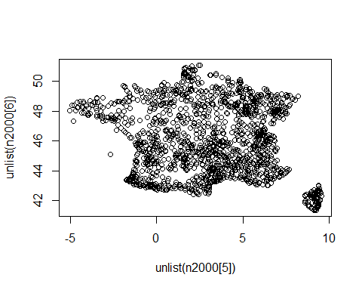
#activite 6
library(ggplot2)
ggplot(data = n2000)+
aes(
x= long,
y= lat,
color= factor(biogeo))+
geom_point()
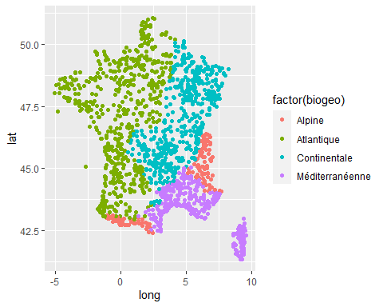
#activite 7
summary(n2000)
## no code nom surf
## Min. : 1.0 Min. :1776 Length:1561 Min. : 0
## 1st Qu.: 431.0 1st Qu.:5771 Class :character 1st Qu.: 322
## Median : 854.0 Median :6729 Mode :character Median : 1511
## Mean : 846.3 Mean :6354 Mean : 6652
## 3rd Qu.:1268.0 3rd Qu.:7418 3rd Qu.: 6059
## Max. :1672.0 Max. :7920 Max. :346184
## long lat alt nbcom
## Min. :-5.060 Min. :41.35 Min. :-500.0 Min. : 1.00
## 1st Qu.: 0.690 1st Qu.:44.07 1st Qu.: 82.0 1st Qu.: 3.00
## Median : 3.230 Median :45.84 Median : 226.5 Median : 6.00
## Mean : 3.104 Mean :46.03 Mean : 434.9 Mean : 12.08
## 3rd Qu.: 5.590 3rd Qu.:48.09 3rd Qu.: 625.0 3rd Qu.: 14.00
## Max. : 9.550 Max. :51.07 Max. :2688.0 Max. :275.00
## biogeo activplus activmoins
## Length:1561 Min. : 0.000 Min. : 0.000
## Class :character 1st Qu.: 3.000 1st Qu.: 2.000
## Mode :character Median : 6.000 Median : 5.000
## Mean : 6.703 Mean : 6.188
## 3rd Qu.: 9.000 3rd Qu.: 9.000
## Max. :61.000 Max. :61.000

